Regulations:
A18

H.T No

Sreenidhi Institute of Science and Technology
(An Autonomous Institution)
Code No: 7EC01 Date: 27-Jan-2020 (FN)

B.Tech I-Year II-Semester External Examination, Jan/Feb-2020 (Supplementary)
DATA STRUCTURES (CSE and IT)

Time: 3 Hours Max.Marks:70

Note: a) No additional answer sheets will be provided.
b) All sub-parts of a question must be answered at one place only, otherwise it will not be valued.
c) Missing data can be assumed suitably.

Part - A Max.Marks:20

Answer all QUESTIONS.
1. | Define an ADT of Queue and list the applications of Queue. | [2M]
2. | Write the node structure of Circular Linked List. | [2M]
3. | Draw the Complete Undirected Graph on five vertices. | [2M]
4. | Write a short note on the Bubble Sort. | [2M]
5. | Define an Object. | [2M]
6. | Distinguish between Multiple Inheritance and Multilevel Inheritance. | [2M]
7. | What is postfix expression for the infix expression : a+b*c/d-e | [2M]
8. | Is the following tree is AVL tree or not? If yes specify the reason.  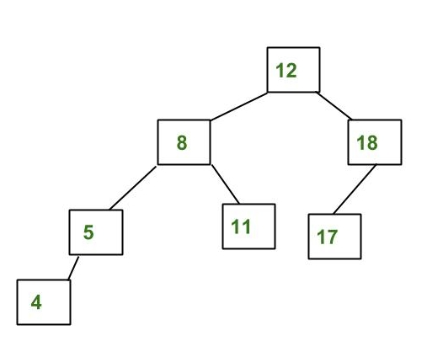 | [2M]
9. | What are C++ access specifiers? | [2M]
10. | Write a C program to perform linear search for finding a key value in a given list. | [2M]

Part – B Max.Marks:50
ANSWER ANY FIVE QUESTIONS. EACH QUESTION CARRIES 10 MARKS.

11. | a) | Write short notes on data structures. Differentiate linear and non linear data structures. | [5M]
 | b) | Define stack. Why do we use stack? Write C code to perform operations on stacks. | [5M]
12. | a) | Consider the following single linked list.  X  1  2  3  4 X  header  N1  N2  N4  N3  Demonstrate the following operations on this list and draw the updated single linked list after each operation.  i). Insert 5 at end ii). Insert 6 at begin iii).Insert 9 after 2  iv). Delete 6 v). Delete 5 vi). Delete 3. | [5M]
 | b) | Compare circular linked list and double linked list. | [5M]
13. | a) | What is the inorder, preorder and postorder traversals for the following binary tree?  .  Z  C  X  V  N  B  A  M | [5M]
 | b) | Consider the graph given below  - Write the adjacency matrix of G1.  - Give Linked list representation of G1.  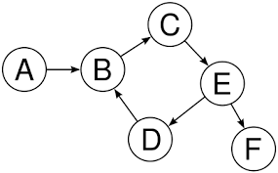  Fig. Graph G1 | [5M]
14. | a) | Sort the following elements using Quick Sort.  40, 32, 75, 17, 15, 22, 54, 12 | [5M]
 | b) | Illustrate about Min-Heap and Max-Heap with an example. | [5M]
15. | a) | Explain about Object Oriented programming concepts. | [5M]
 | b) | Does C++ support Constructors? If so what are the types of constructors and describe each with an example. | [5M]
16. | a) | Write a C++ program for operator overloading. | [5M]
 | b) | Can we implement templates in C++? Justify your answer with an example. | [5M]
17. | a) | Given an empty Queue, after performing ENQUEUE(4), ENQUEUE(5), DEQUEUE(), ENQUEUE(3), DEQUEUE(), ENQUEUE(6), ENQUEUE(7). What are the Rear and front pointers of queue? | [3M]
 | b) | What are the different types of Linked Lists? List any four applications of Linked Lists. | [3M]
 | c) | Differentiate between DFS and BFS. | [4M]
18. | a) | Write a C code for Insertion Sort using arrays. | [3M]
 | b) | Write a short note on Destructors. | [3M]
 | c) | With an example illustrate the purpose of Dynamic Memory Management Operators. | [4M]

-- 00 -- 00 –

